

PRC CAMPUS
Spring 2018

Welcome Squad Volunteer Packet

If you don’t know an answer or cannot find one in this packet, please contact one of the secretaries (LH158, F243, L225, J240) or the Information Desk (Lawler Hall).



Thank you for volunteering!

Frequently Asked Questions

Where is my classroom? | Make sure the student is at the right campus first for that particular class! Double check the Section Number, the letter of which indicates the campus. Send them to Advising (F109) if they need to resolve campus schedule issues.
Do I need a parking sticker? | Yes. Students can get their free parking stickers at the Information Desk in Lawler Hall, or Student Life Office in Alumni Hall (A185).
Do I have to have a student ID card? | Yes. You cannot use the Lab, Testing Center, Fitness Center, etc. without it. It also doubles as your library card.
Where do I get my student ID? | IDs are made in the Student Life Office (A185).
I want to add and drop a class. What do I need to do? | Students can add classes online up to the 4th day of the semester. They should see Advising (F109) if they have questions. Drops and withdrawals – including total withdrawal - are done online through student’s CougarWeb account.
What is the difference between “L” and “LH”? | All classes with LH are in Lawler Hall. All classes with L are in the library. Any classes in library on the first floor can be accessed by a separate entrance on the east side of the library. You cannot get there by going into the library itself.
Where is there a computer I can use? | The student can go to the Computer Lab (H120) to use a computer. There are also a few computers in F109 for add/drop schedule look-up.
I want to add a class, but it is full. What do I need to do? | Look for options at different times and locations. Overloads are an exception. For consideration of such an exception, have them contact the appropriate division office (Academic Associate Dean).  *Math & Natural Sciences DOES NOT allow overloads.*
There is nothing on my schedule now! What happened? What can I do? | Chances are they forgot to pay and were dropped from all their classes. Tell student to go online and re-register. If student paid & thinks that there is a mistake, then send them to the Cashier’s office (F110).
My class was canceled and I need another class. What do I do? | First make certain the cancellation on the door is the correct class. Students can add classes on-line through the 4th class day. Course Cancellations=100% refund
I went to my class but it was the wrong class or no one was there. | Check to make sure the student isn’t in an evening class instead of a morning class or vice versa. Also check to make sure he/she is on the correct campus.

PRC Frequently Visited Areas

Academic Advising Office: F109
Admissions and Records Office: F109
Bookstore: F159
Bursar’s/Cashier’s Office: F110
Career Center: F172
Computer Lab: H120
Counseling Services/Mental Health Services: F 144
Division Offices
Academic Affairs – Transfer Room Phone
Science, Math & Physical Education J140 X1705
Business, Social & Behavioral Sciences, Criminal Justice J140 X1006
Communications, Humanities and Fine Arts J140 X1006
Academic Affairs – Workforce
Computer Science & Information Technology H245 X1903
Computer Networking & Engineering H245 X1903
Engineering Technology H245 X1903
DE, Culinary Arts, Hospitality, Marketing, Paralegal H245 X1903

Financial Aid Office: F109
Instruction Office: F243, L222, J240, LH158, U111
Library: L Building
Math Lab: F148
Student Engagement (Student IDs): A185
Testing Center: F209
Veterans Resource Center: F141
Writing Center: LH141
Students who want to drop off their meningitis vaccination records should be sent to Admissions in F109.

Special Extended Hours @ PRC

STUDENT & ENROLLMENT SERVICES
Academic Advising, Financial Aid, Admission, Student Engagement (Picture IDs)

Day Date Time In Line By
Monday January 15 Campus Closed
Tuesday January 16 7:30 am – 8pm 6 pm
Wednesday January 17 7:30 am – 8pm 6 pm
Thursday January 18 8:00 am – 8pm 6 pm
Friday January 19 8:00 am – 5pm 3 pm
Saturday January 20 9:00 am – Noon

Please advise students that they will need to be in line at least TWO HOURS prior to the posted closing time.

BOOKSTORE

Day Date Time
Monday January 15 Campus Closed
Tuesday January 16 7:45 am – 8:00 pm
Wednesday January 17 7:45 am – 8:00 pm
Thursday January 18 7:45 am – 5:00 pm
Friday January 19 7:45 am – 5:00 pm
Saturday January 20 11:00 am – 3:00 pm

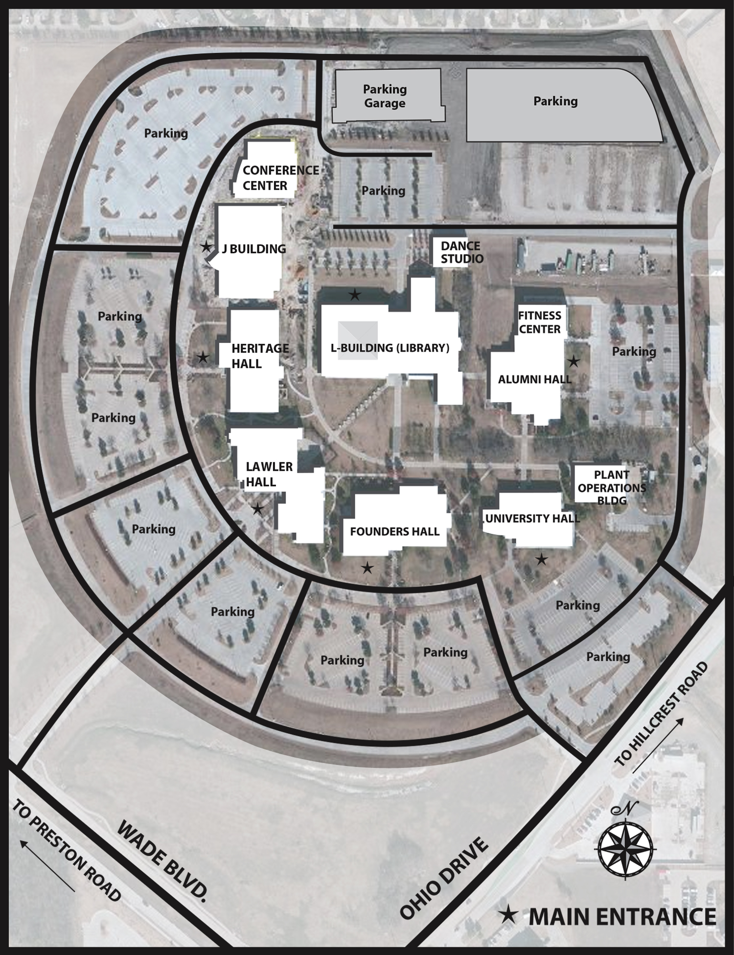



Preston Ridge
Campus
Map
“A” Classrooms/Offices Alumni Hall
ACCESS Office Founders Hall, F144
Academic Advising Founders Hall, F109
Admissions Founders Hall, F109
Art Labs Library, L131/L140

Bookstore Founders, F159

Campus Police Lawler Hall, LH179
Career Center Founders Hall, F172
Cashier Founders Hall, Atrium
Computer Lab (open) Heritage Hall, H120
Conference Room Conference Center
Cougar Den & Café Alumni Hall
Counseling Services Founders Hall, F144
Culinary Arts Alumni Hall

Dance Studio LC 104
Dean of Students Office Founders, F127
Dean of Student/Enrollment Services Office Founders, F136
“F” Classrooms/Offices Founders Hall
Financial Aid Founders Hall, F109
Fitness Center Alumni Hall, A 138

Gymnasium Alumni Hall, A118

“H” Classrooms/Offices Heritage Hall
Information Center Lawler Hall, Atrium
Institute for Culinary/Hospitality Education Alumni Hall

“J” Classrooms/Offices J Building

“L” Classrooms/Offices L Building/Library
“LC” Classrooms Dance Studio
“LH” Classrooms/Offices Lawler Hall
Library L Building
Lost & Found Alumni Hall, A 185

Math Lab Founders Hall, F 148
Music Wing L Building

Red Room Alumni Hall, A 150

Scantron Vending Machine Founders Hall, Atrium
Science Den Lawler Hall, LH 202
Student/Enrollment Services Founders Hall, F 109
Dean Founders Hall, F136
Associate Dean Founders Hall, F128
Student IDs Alumni Hall, A 185
Student Engagement Alumni Hall, A 185

Technology Labs Heritage Hall
Testing Center Founders Hall, F209

“U” Classrooms/Offices University Hall

Veterans Resource Center Founders Hall, F 141
Vice President/Provost Office J Building, J 230

Writing Center Lawler Hall, LH141

