
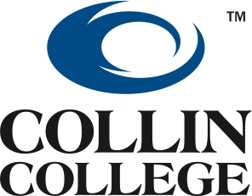

Fall 2016
PSB Allied Health Exam
Day/Date Time Room
Wednesday, December 14, 2016 | 9:00 A.M. | A109, CPC – Testing Center
Wednesday, December 14, 2016 | 1:00 P.M. | A109, CPC – Testing Center
Thursday, December  15, 2016 | 9:00 A.M. | A109, CPC – Testing Center
Thursday, December 15, 2016 | 1:00 P.M. | A109, CPC – Testing Center

To register for an exam date:
Please come to the Central Park Campus in McKinney and pay for your exam at the cashier’s office. Please take your receipt to the Dental Hygiene Office (A119) to schedule your exam date. Dates are filled on a first come, first serve basis.

All PSB exams must be taken by December 31, 2016 to apply by the application deadline. It is the responsibility of the applicant to ensure that results are into the Dental Hygiene department by the application deadline of 5:00 P.M. Tuesday, January 31, 2017
THERE WILL BE NO EXCEPTIONS.

