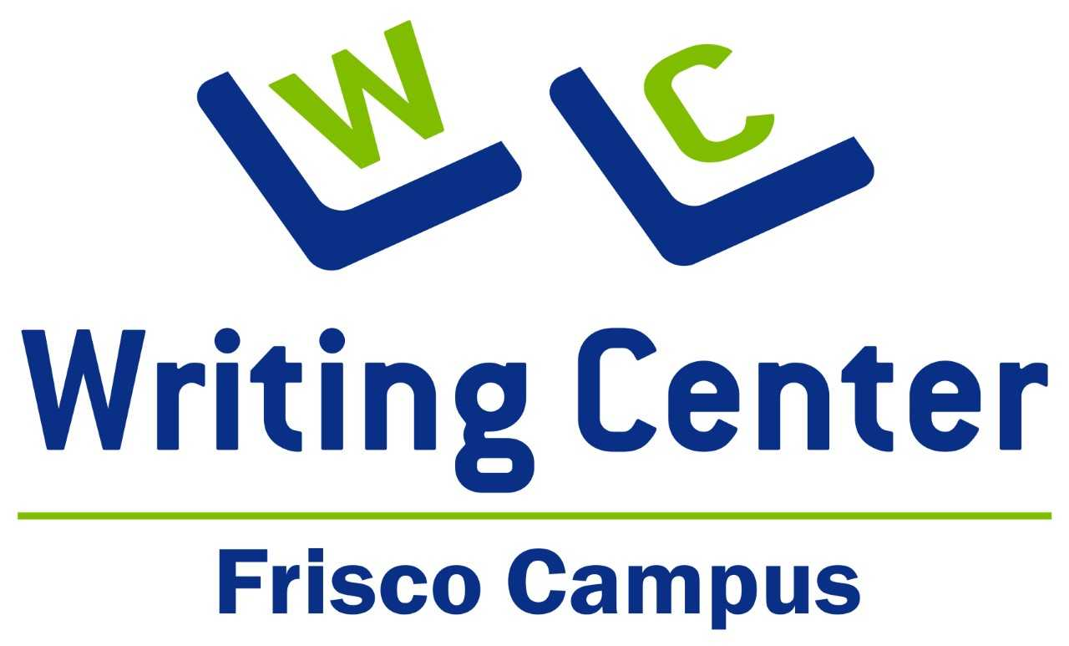
Workshops
Summer 2024

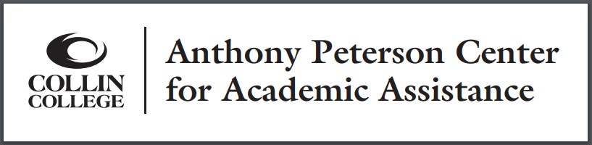
Reserve your spot at a workshop by going to the Schedule Tutoring/TracCloud tile in OneLogin. Choose the Online workshops schedule, even if you plan to attend in person. Most workshops will take place on campus and on Zoom simultaneously, while a few are on Zoom only.
If no Zoom link is listed in the individual description, use this Zoom link: https://us02web.zoom.us/j/3432868195.
Drop-ins, both in person and virtually, are welcome but be sure to tell the presenter if you need verification of attendance.

Collin College
9700 Wade Blvd.
Frisco, Texas 75035
972-377-1576
Email: prcwritingcenter@collin.edu

Tuesday, June 11  1:00 PM – 2:00 PM | Be Concise  Presenter: Nathan Conard, Writing Center Consultant  Expressing your ideas succinctly matters. Too many words can clutter an essay, leaving readers inattentive or confused. We'll discuss how to enhance your writing by removing verbiage and redundancy to maximize the force of your message. | LH-142 & Zoom
Monday, June 17  5:00 PM - 6:00 PM | Academic Writing: Tips to Keep in Mind  Presenter: Brian Martin, Writing Center Consultant  This workshop will provide students with the necessary tools for writing with greater clarity and logical reasoning. Here, students will learn the "moves that matter in academic writing" — a phrase coined by authors Gerald Graff and Cathy Birkenstein in their book They Say/ I Say. | LH-142 & Zoom
Wednesday, June 19  4:00 PM – 5:00 PM | Get Ahead of Writer's Block: Brainstorming and Planning  Presenter: Emily Buziewicz, Writing Center Consultant  From understanding the prompt through conquering the conclusion, we will discuss how to be ready for every stage of the writing process. Be ready to combat writer's block and write solid essays! | LH-142 & Zoom
Tuesday, June 25  11:00 AM - 12:00 PM | Including Current Events and Opinion Pieces in Your Research  Presenter: David Toye, Reference Librarian  Learn how the library provides access to current issues of newspapers and magazines from around the world and how you can add current events to your research and writing. | LH-142 & Zoom
Sunday, June 30  5:00 PM – 6:00 PM | Reading and Writing Graphically: How Graphic Novels Impact Literacy  Presenter: Noor Jafri, Writing Center Consultant  Graphic novels and comic books have exploded in popularity across bookstores and libraries everywhere. However, many traditional readers question whether this recent trend is a good or bad thing for literacy. We will explore the value and usage of graphic novels as a reading tool, both for children and adults. | ZOOM Only
Monday, July 1  4:00 PM - 5:00 PM | Email Etiquette  Presenter: Monica Davenport, Writing Center Manager  An email to your professor, boss, or other professional needs to follow certain guidelines in order to represent you appropriately. The principles are different from personal emails you may send. Come learn how to communicate effectively and represent yourself professionally through email. | LH-142 & Zoom
Monday, July 15  11:00 AM - 12:00 PM | Learn How to Use 1st, 2nd, and 3rd Person Points of View  Presenter: Regina Burns, Writing Center Consultant  What are first-person, second-person, and third-person points of view? When should you use them in your academic writing? What is the preferred point of view for a college application essay? Get answers and discover the best practices to implement viewpoints in your writing. Plus, this workshop will incorporate fun speed rounds to strengthen your effective use of each type. | LH-142 & Zoom
Tuesday, July 16  3:00 PM – 4:00 PM | Annotated Bibliography: How to Do it Right  Presenter: Lopa Banerjee, Writing Center Consultant  The annotated bibliography provides a crucial foundation for research-based assignments. However, students often need guidance on how to properly summarize, evaluate, or interpret a particular source, keeping in mind the assignment guidelines. This comprehensive workshop will familiarize students with not only the basics of writing an annotated bibliography, but also with its style and formatting. | LH-142 & Zoom
Tuesday, July 23  5:00 PM – 6:00 PM | Historical Research Treasure Hunt  Presenter: Linda Andrews, Reference Librarian  Historical research studies the meaning of past events in an attempt to interpret the facts and explain the causes, as well what their effect may be on present events. How did people and groups triumph over adversity? How do the Kardashian family and the Medici family compare? And you thought history was boring? It’s not! Come learn how you can participate in the treasure hunt of historical research. | L-115 & Zoom
Thursday, July 25  4:00 PM – 5:00 PM | Key Words as Keystones: Constructing a Well-Organized College Essay  Presenter: Alisa Bovda, Adjunct Professor & Writing Center Consultant  In this workshop you’ll learn a way to construct an organized college paper that can be adapted across a variety of courses and writing assignments. We will focus on the importance of key words as an organizing element of college papers. | LH-142 & Zoom
Wednesday, July 31  4:00 PM – 5:00 PM | Reaching Your Word Count Without Using Fluff  Presenter: Cheryl Clark, Writing Center Consultant  Is your paper 250 words long, and you need 500? Maybe you're short a paragraph or two. Come to this workshop to learn how to add depth, complexity, and specificity to your paper without the extra padding and repetition that can ruin a paper. | LH-142 & Zoom
Friday, August 2  11:00 AM - 12:00 PM | Formal Academic Tone  Presenter: Darcy Rudnick, Writing Center Consultant  In this workshop, you will learn what language use is appropriate for formal academic essays. Activities to practice this tone will be included. | LH-142 & Zoom
Monday, August 5  4:00 PM – 5:00 PM | Improve your Grammar in 60 Minutes  Presenter: Monica Davenport, Writing Center Manager  Tired of losing points on your essays due to grammar errors? This workshop addresses the most common grammatical stumbling blocks and provides tips for identifying and fixing them in your writing. | LH-142 & Zoom

